**ASSIGNMENT – III**

|  |  |
| --- | --- |
| Project Name | Personal Expense Tracker |
| Student Name | Navaneeth K B |
| Student Register Number | PNT2022TMID02770 |

QUESTIONS:

1.Create a bucket in IBM object storage.

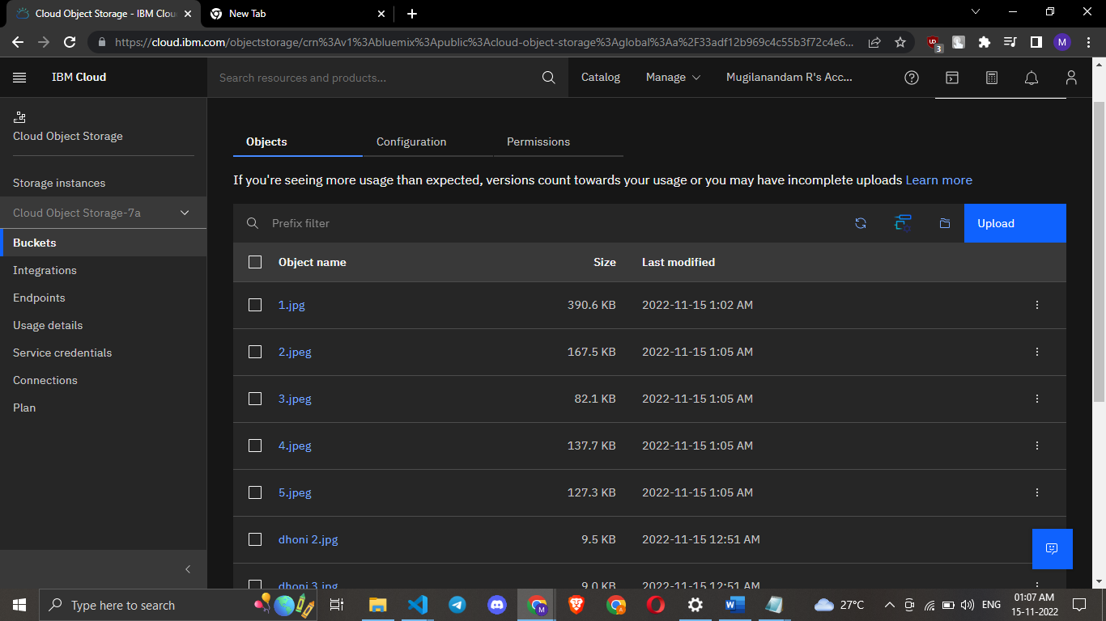

2. Upload 5 images to IBM object storage and make it public. Write html code to displaying all 5 images.

